Blackjack Betting and Strategy Analysis

Kenny Darrell M01784329

QA 771 Simulation Modeling

Blackjack is game played in mostly all casinos were each player is dealt cards and plays against a dealer playing for the House. Each player places a bet and is dealt two cards face up and the House is dealt two cards, one face up and one face down. Then players have a decision of what to do next in order to win the bet by coming closer than the dealer to 21 without going over. In this analysis player’s decisions and betting strategies are observed to see which lead to more optimal returns. An Arena model will replicate the play and collect data on the varying player types to see which methods work better.

The data and information that this model needs are mainly the rules for Blackjack that is to be programmed into the logic of the Arena model. These rules of the game vary by where it is played. The rules in use in the simulated Blackjack game are fairly typical, players are must place a bet before each hand, where there is a $1 minimum per hand. All cards have a numeric value that will contribute the players hand based on the card type. An Ace is worth either a 1 or an 11 in the player’s favor. Numeric cards, 2 through 10, have a face value of the card type. All face cards; Jack, Queen, and King, are worth 10. A first card is dealt face up to all players and the House, and then a second card is dealt face up to all players and face down to the house. The players hand is then calculated from the values of their two cards. A decision must be made by all players, in the order they were dealt, as to what their next move should be. The decisions that the player can make are to stay, hit, double down, or split. Decisions by players are made based on their current hand the face up card of the House. A player can choose to stay meaning they wish to receive no more cards in order to be the House and the decision is moved to the next player. A player can double down, he must double his initial bet and is will receive on more card and move to the next player. A player can hit in order to be dealt another card, and then he is given the option to hit or stay. The hit limit is five; no hand can contain more than seven cards. A player can split only if he has a pair, both cards are of the same type, which means that his cards are split into two separate hands and he is dealt a second card for each. If a player splits he must offer up another bet for the second that is equivalent to the first. The split hands are played the same as a regular hand except that he is not allowed to split either of these hands. If a player is dealt a Blackjack, an ace and card with a value of ten, he is paid 150% of his bet, unless the dealer has a Blackjack as well in which case there is a push. After all decisions by players have been made play is transferred to the dealer to play for the House. He does not have choices but must follow a specified set of rules for how he plays. He only has the option to hit or stay. He must hit if his hand is less than 17, so long as it does not take him over 7 cards in total. If he has 17 or more he must stay. He must pay even money to all hands higher than his. The bets will be taken in the case of tie between a player and the house, except for the push on both Blackjacks as mentioned above. After all bets are settled the cards are discarded and new bets are wagered. A new hand will start exactly as the last.

The model is making the assumption that there is no option to for players to surrender or take insurance which in some rules allow this. The model is also making the assumption that all cards left in the shoe are equally as likely to be drawn as any other card which might not be the case at a casino if they are operating unfairly. There could still be a higher chance of getting a two over a four but that would be due to more twos left in the shoe than fours. There is also an assumption that when the shoe of eight decks has been depleted to 25 cards a fresh shoe will be introduced. In many casinos this is done via a cut card, this is a solid red card that is not playable, that is placed by a player into the deck after shuffling the previous shoe. The dealer cuts the deck at this location and usually places this card towards the bottom third of the shoe. When this card comes up it indicates that the cards will either be shuffled or a new shoe will be implemented after the current hand is finished. The placement of the cut at 25 cards in the simulation is very advantageous to a card counting player as they are able to see many more cards on average than a random placement would allow.

In the simulation cards are dealt from the shoe via a new entity being created and sent to the logic of the model. The shoe will contain eight decks of 52 cards, 416 cards in total, resulting in 32 cards of each type. This will lead to the following shoe composition; 32 Aces having a card value of 11 or 1, 32 numeric cards for each card value of 2 through 9, and 116 cards with a value of 10 for Tens, Jacks, Queens, and Kings. There is a variable for cards remaining in the shoe as well one for the number of remaining cards of each card value. When a card is dealt it will be assigned a card value from a discrete probability distribution shown in Formula 1. As an example P(x = 10) = $\frac{X_{10}}{D}$ will mean that the current card has a probability $\frac{X_{10}}{D}$ of being assigned a card value of 10; it’s a Ten, Jack, Queen, or King, where X10 is the number of cards remaining that have a value of 10 and D is the number of cards remaining in the shoe.

P(x) = (P(x = 11) = $\frac{X_{11}}{D}$, P(x = 2) = $\frac{X_{2}}{D}$, P(x = 3) = $\frac{X_{3}}{D}$, P(x = 4) = $\frac{X_{4}}{D}$, P(x = 5) = $\frac{X_{5}}{D}$,

P(x = 6) = $\frac{X_{6}}{D}$, P(x = 7) = $\frac{X_{7}}{D}$, P(x = 8) = $\frac{X_{8}}{D}$, P(x = 9) = $\frac{X_{9}}{D}$, P(x = 10) = $\frac{X_{10}}{D}$)

This is implemented using Arena’s DISC function with card values and their respective cumulative probabilities. After the card has been assigned its value the number of cards remaining in the shoe and the number of cards of that type will both be decremented by 1. After the card has been given a type the entity will be sent to logic that will distribute it to a player as appropriate.

The initial deal of a hand will occur next. The cards are dealt out by sending them to alternating players so that each player and the house have two cards. The decision process of the deal will then start. The order is Player 1 first, Player 2 second, Player 3 third, and the House last. Each Player has logic that will allow them to make their decision based on their two cards and the dealers face up card. Player 1 will make his initial decision based off of the Casino Blackjack Cheat Sheet as seen in the appendix. If he has been dealt Blackjack the decision will move to the next player. Using only the values of his two cards and the dealers face up card he can hit, stand, split, or double down. If he decides to double down he will double his bet, which is always 5$ for Player 1, and will be dealt one more card before moving to the next player. For a split he will be dealt another card for each hand. His first hand will be played in the section of logic as regular only he may not split again. There is a separate set of logic for his second hand that exactly the same as the first. If he chooses to hit he will continue to be dealt cards until he stays or hits five times. After the first hit his logic reduces to either hit or stay. His hand value and a variable for busting will be calculated after each card he receives. If there is a bust and he has an Ace, the value of the Ace will be dropped to 1 and his hand value and bust will be recalculated and given the hit or stand option.

Player 2 is simpler than Player 1. He plays a very conservative strategy where he will stay below a set value. If his hand total is less than this value he will hit, greater than or equal to this limit and he will stay. He will be afforded the same number of hits and will use the same logic to calculate his hand value and whether there is a bust. Player 2 wager will be $5 every hand the same as Player 1. Player 3 is exactly the same as Player 1 except he can modify his bet based on the count. There will be a count variable that will begin every shoe with a value of 0. The count will increment by 1 for every 2, 3, 4, 5, and 6 that is dealt. The count will decrement by 1 for every 10, Jack, Queen, King, and Ace that sis dealt. A true count will be implemented by dividing this count by the number of decks left to be dealt. The Dealer will then make his decisions. The logic will simply force him to hit below 17 and to stay at or above 17.

After the hand is over there is a section that will determine how players are to be paid out. If a player receives a Blackjack and the dealer does not an amount of 1.5 multiplied by the players bet will be added to their bank roll. If the dealer receives a Blackjack there will be a push between him and any player with a Blackjack, all other players losing. If the player busts or his hand total is less than the dealers that didn’t bust his value of his bet will be taken from his bankroll. If the player doesn’t bust and his hand is higher than the dealer or the dealer busts the value of his bet will be added to his bankroll. In the non-blackjack cases were the player doubled down the value used for this will be 2 times his original bet. In the case where a player split he will have a bet for each hand and blackjack and double down multipliers will only be for hand so that each are counted independently.

After the payouts all variables related to that hand are cleared out to start the next hand. Another section of logic at the end of the hand will determine if a player has gone bankrupt, there bankroll has been depleted to zero. If a player is bankrupt a fresh player will be created of the same type with a bankroll of $100. Once 10 players of a specific type have gone bankrupt output statistics will be calculated for the type. The number of hands played will be the total number of hands played up to that point divided by 10. This will be the average number of hands played for the 10 players. The average return ratio will be calculated by the total amount earned divided by the total value of bets made by the ten players having a range of zero to 1.5. This is not the expected return usually associated with a game of risk that is the percentage return you would expect on your bet. This parameter is very similar to the expected return except that it shows all hand outcomes. The expected return does take a push into consideration and would have a range of zero to 2.5. Players will continue to be generated after the ten bankrupts so that the game is unchanged for the other types but will have no impact on statistics. Once ten players from all three types have gone bankrupt the replication will end, causing either the start of a new replication or the end of the simulation.

A model where player 3 was equivalent to player 1 , using no count for his bet, and player 2 had a limit were he would not hit at 13 or above was tested first a base for future comparison. The simulation ran the model for 500 replications. The average of the hands played parameters was (193.80, 154.78, 198.92) with half widths of (4.17, 2.71, 4.60) for player 1, 2, and 3 respectively. The average of the return parameters were (.4611, .4427, .4612) with half widths of (0.00, 0.00, 0.00) for player 1, 2, and 3 respectively. Figure 1 shows the comparison of the average number of hands played for players 1 and 3. This is a visual Paired T-Test of the 500 parameters at a 95% confidence level with the order of difference player 1 – player 3 obtained from the Arena Output Analyzer. The test used here will be equivalent to tests shown letter with the exception of possible differences in sample size. From this it is concluded that if two players use the same strategy that the numbers of hands they can play before going bankrupt are statistically the same. Figure 2 shows the comparison of average return for player 1 compared to player 3. This shows the same result that they are statistically identical. Since player 1 and player 3 are regarded as equal, the same parameters were tested for player 1 to player as seen in Figures 3 and 4. Player 2 seems to have a significantly worse strategy as the estimated mean difference in hands played was 39. The result is the same for average return having an estimated mean difference of 0.0185.

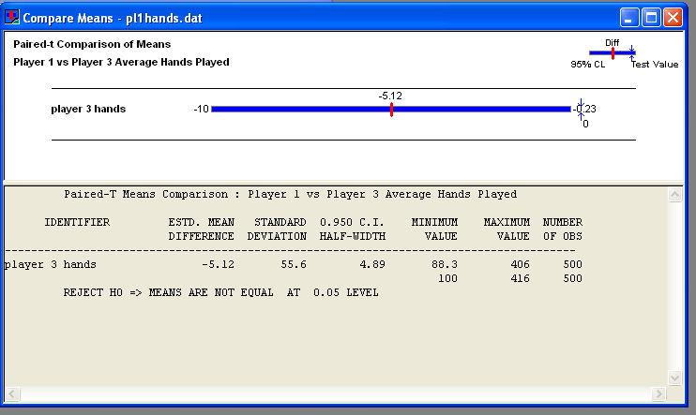

Figure 1, Comparison of Average Number of Hands Played for Player 1 and Player 3

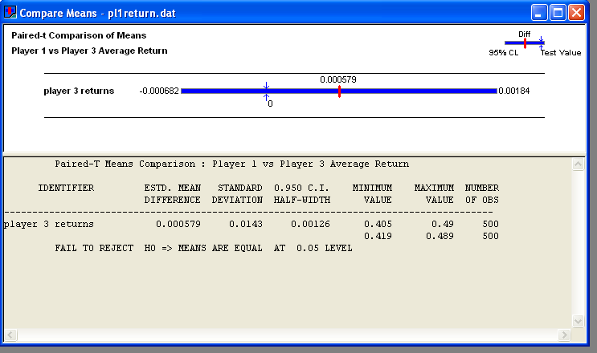

Figure 2, Comparison of Average Return from Player 1 and Player 3

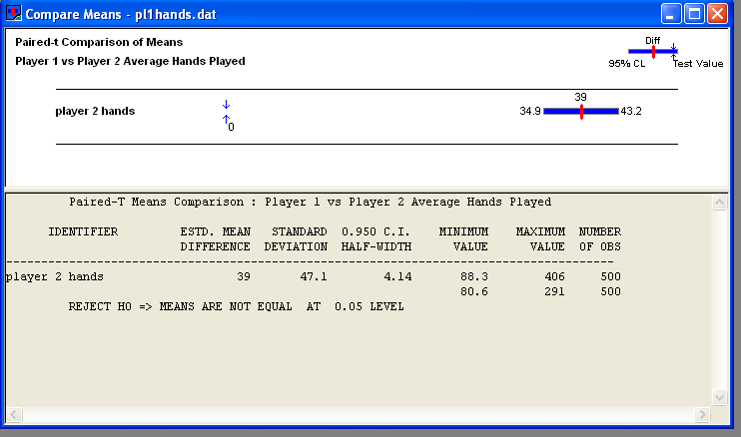

Figure 3, Comparison of Average Number of Hands Played for Player 1 and Player 2

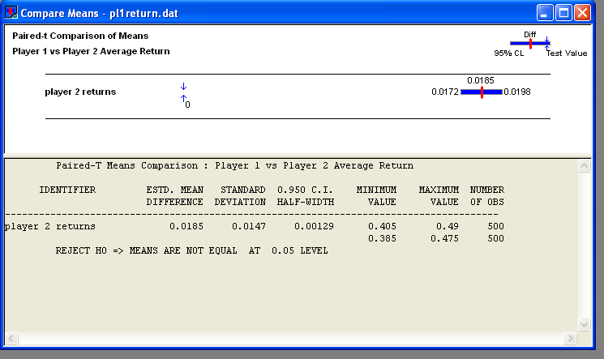

Figure 4, Comparison of Average Return from Player 1 and Player 2

A second model was simulated which gave player 3 the ability to change his bet based on the count. For this model he will only be able to adjust his bet downward based on a negative count. If the count is zero or greater he will employ his usual $5 bet, if it is less than zero he will subtract the true count form his bet until he reaches one a minimum bet. The new player 3 output values calculated from 500 replications are 244.72 average number of hands played with a half width of 5.23 and 0.4621 average return with a half width 0.00. Figures 5 and 6 shows the results of hands played and return for a comparison of player 1 and player 3 using card counting to adjust his bets. While using the card counting method player three can now play significantly many more hands that player 1, a mean difference estimate of 50.9. The average returns on the other cannot be deemed any different statistically. This would lead me to believe that player 3 is not making anymore more off of his bets than he did before he is only playing longer because his bets were smaller at certain times. These times when the bets were smaller meant that the count was very low which the lower the count the more advantage the house has because they are less likely to bust on their forced hits and players are less likely to receive a Blackjack.

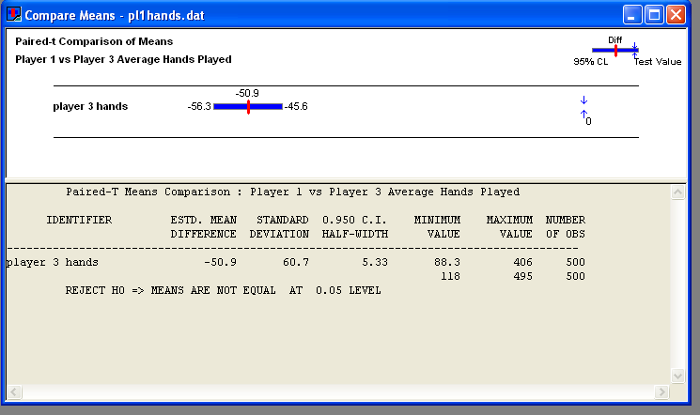

Figure 5, Comparison of Average Number of Hands Played for Player 1 and Player 3 (Card Counting)

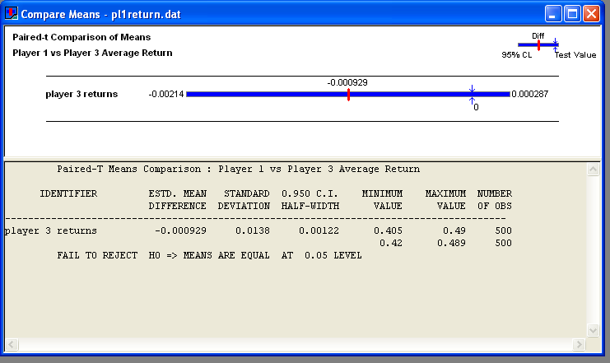

Figure 6, Comparison of Average Return from Player 1 and Player 3 (Card Counting)

The simulation ran to try to optimizet he strategy of player 2 used a model that only collected his output statistics and quit when all ten players 2’s had bankrupted. It was run using PAN for a range of limits on players 2’s hitting threshold from 18 to 11. The control variable used was placed inside the logic a player 2 used to hit. If his hand was at or above the control variable he would stay. The range has a starting point 18 with nothing above being tested as it seems illogical to hit when you have a hand that the dealer cannot hit at. The lower value of 11 was a minimum because you cannot bust regardless of the card dealt below 11. Figure 7 shows the PAN configuration and the output for average number of hands played. Figure 8 shows the average return for player 2 for the range of the control variable used. There seems to be a trend here that has an optimal value at 13, but based on the number of runs used there is statistical difference between 12, 13, and 14. The red segments contain the maximum value of the parameter of interest with 95% confidence.

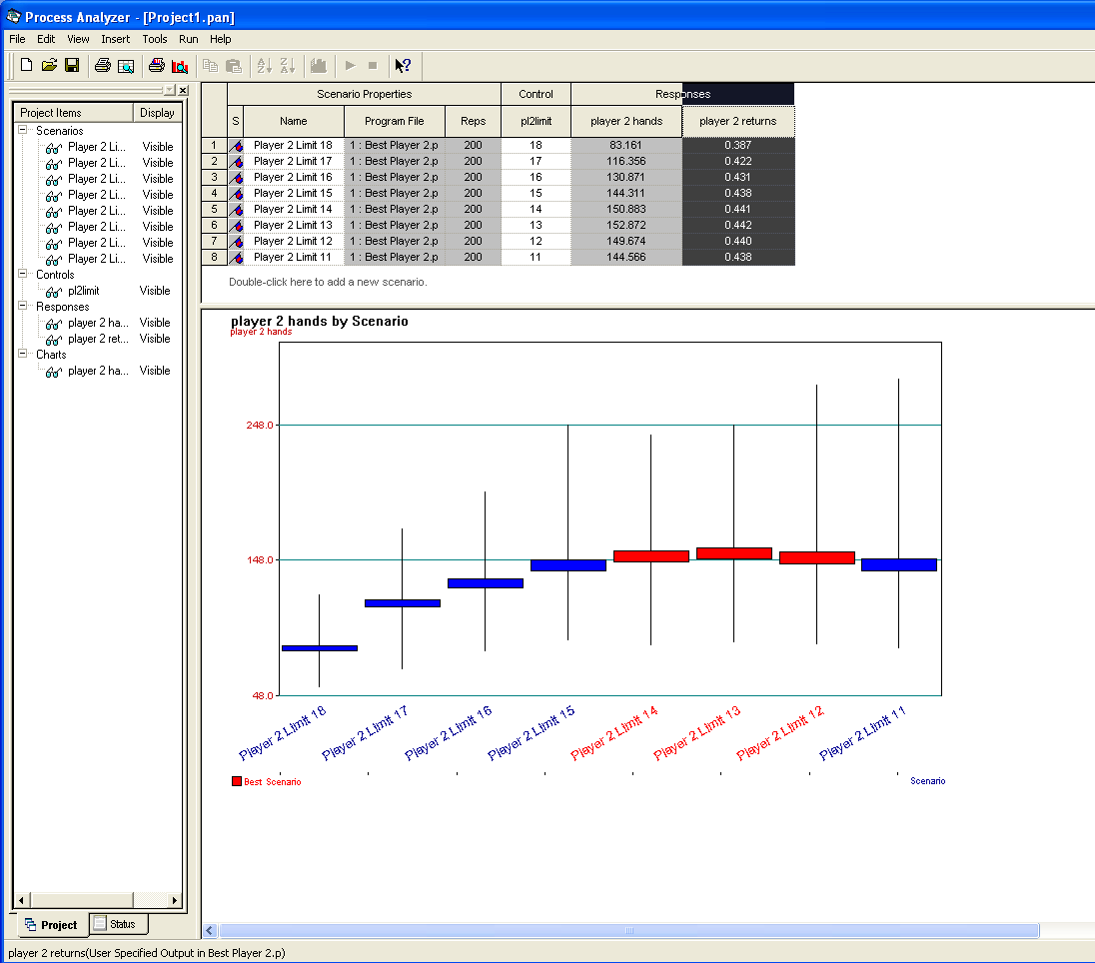Figure 7, Player 2 Average Number of Hands Played Optimizing Hit Below Threshold

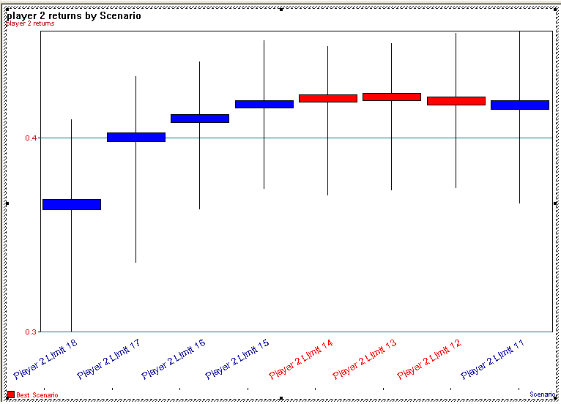

Figure 8, Player 2 Average Returns Optimizing Hit Below Threshold

Another simulation was run to try to optimize the strategy of player 3.

because you cannot bust regardless of the card dealt below 11. Figure 7 shows the PAN configuration and the output for average number of hands played. Figure 8 shows the average return for player 2 for the range of the control variable used. There seems to be a trend here that has an optimal value at 13, but based on the number of runs used there is statistical difference between 12, 13, and 14. The red segments contain the maximum value of the parameter of interest with 95% confidence.

Figure 8, Optimal Player 2 Average Return

* If player 1 and player 3 have the exact same strategy will they have the exact same returns, This is really a validation, use the output analyzer to compare their return and hands played form 200 replications
* Does counting make an impact; compare the statistics from player 1 and player 3. Use output analyzer to compare their returns and hands played for 200 replications, which player is better, why.
* Is there a strategy for the counter that is better than others? Vary a the limit parameter pan over say 11 to 17 to see what is his best strategy.
* Is there best value for player 2 to use as a limit, A very simple strategy that he will not hit below a certain value. What value of this limit will provide the best return.110 reps

The solution, what am I trying to show and how

The results

The conclusion